# Request Processing Models

## Worker Process Isolation Mode

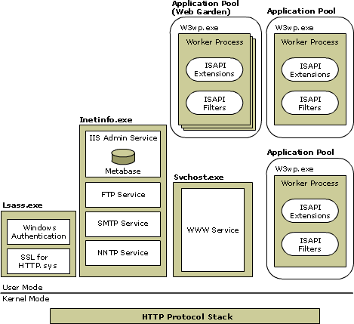

## IIS 5.0 Isolation Mode

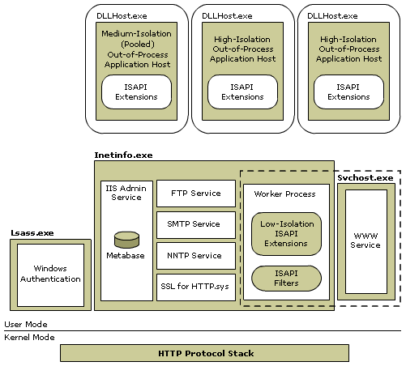

|  |  |
| --- | --- |
| [Windows Server System](http://www.microsoft.com/windowsserversystem/default.mspx) | Internet Information Services (IIS)  6.0 Cribsheet |

# IIS Services

|  |  |  |  |  |
| --- | --- | --- | --- | --- |
| Service | | Description | Core Component | Host |
| Name | Short  Name |
| World Wide Web Publishing Service (WWW service) | W3SVC | Delivers Web publishing services. | Iisw3adm.dll | Svchost.exe |
| File Transfer Protocol (FTP) | MSFTPSVC | Allows file uploads and downloads from remote systems. | Ftpsvc2.dll | Inetinfo.exe |
| Simple Mail Transfer Protocol (SMTP) | SMTPSVC | Sends and receives electronic messages (e-mail). | Smtpsvc.dll | Inetinfo.exe |
| Network News Transfer Protocol (NNTP) | NNTPSVC | Distributes network news messages. | Nntpsvc.dll | Inetinfo.exe |
| IIS Admin Service | IISADMIN | Manages the metabase. | Iisadmin.dll | Inetinfo.exe |

# IIS Metabase

## Metabase Elements

IIS 6.0 replaces the single binary file (MetaBase.bin) of earlier IIS versions with two XML files: **MetaBase.xml** and **MBSchema.xml**.

IIS stores these files in the **systemroot\System32\Inetsrv** folder of your computer. To view and modify these files, you must be a member of the Administrators group.

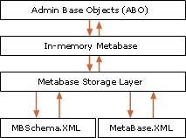The metabase consists of the following elements:

* **MetaBase.xml** file. This file stores IIS configuration information that is specific to an installation of IIS.
* **MBSchema.xml** file. This file contains the metabase schema. The MBSchema.xml file is a master configuration file that defines default attributes for all metabase properties and enforces rules for constructing and placing metabase entries within the metabase.
* **In-memory metabase**. The in-memory metabase contains the most current metabase and metabase schema configuration. The in-memory metabase accepts changes to the metabase configuration and schema, storing them in RAM, and periodically writing changes to the on-disk metabase and metabase schema files.

# Managing Web Sites Using Scripts

|  |  |  |
| --- | --- | --- |
| IIS Area/Component | Script | Tasks |
| Web sites | Iisweb.vbs | *Create, delete, start, stop, pause, and query or list Web sites.* |
| FTP sites | Iisftp.vbs | *Create, delete, start, stop, pause, and query or list FTP sites. Query and set Active Directory properties for a users FTP home directory (use in FTP user isolation).* |
| Web virtual directories | Iisvdir.vbs | *Create, delete, or list the Web virtual directories of a given root.* |
| FTP virtual directories | Iisftpdr.vbs | *Create, delete, or list the FTP virtual directories of a given root.* |
| Back up and restore IIS configuration | iisback.vbs | *Create, delete, restore, and list backup copies of IIS configuration.* |
| Export or import IIS configuration | Iiscnfg.vbs | *Export or import an IIS configuration to or from an XML file; copy the metabase and schema to another computer; and save configuration changes to disk.* |
| Applications and dynamic content services | Iisext.vbs | *Configure and manage applications, Web service extensions (like ASP and ASP.NET), and individual files.* |
| Application pools and their worker processes | Iisapp.vbs | *List the worker processes (W3wp.exe) currently running and the application pool each one serves.* |

# HTTP.sys Reason Phrases (IIS 6.0)

The following reason phrases can appear in an HTTP.sys error log file to describe the error that caused the log file entry:

**Connection_Abandoned_By_AppPool** - This reason phrase indicates that the error was caused by a worker process stopping unexpectedly and orphaning requests.

**Connection_Dropped** - This reason phrase indicates that a zombie connection was dropped by IIS and not resolved correctly.

**Various connection time-out errors**

These reason phrases include the following various connection time-out errors:

* Timer_ConnectionIdle. There has been no new data sent over the connection since the last send from the client to server, and the connection timed out.
* Timer_HeaderWait. A connection was initiated with the server, but the headers for the request were not received in a timely manner.
* Timer_MinBytesPerSecond. The minimum throughput rate was not maintained.
* Timer_EntityBody. The connection expired while waiting for the entity body to arrive.
* Timer_AppPool. The connection expired because the request waited too long in an application pool queue.

**Various errors**

These reason phrases include the following errors, most of which are parse errors:

* BadRequest
* Verb
* URL
* Header
* Hostname
* Invalid_CR/LF
* Number
* FieldLength
* RequestLength
* Forbidden
* LengthRequired
* Precondition
* EntityTooLarge
* URL_Length
* Internal
* N/I

**Internal -** This reason phrase indicates that an HTTP Error 500, internal server error, occurred.

**N/I -** This reason phrase indicates that an HTTP Error 501, not implemented, occurred.

**All 503 errors -** The 503 errors are service unavailable errors. These reason phrases include the following 503 errors:

* N/A. The service is unavailable.
* ConnLimit. The site connection limit has been reached.
* AppOffline. Because of rapid fail protection, the application was taken offline by IIS.
* QueueFull. The application request queue is full.
* Disabled. The administrator has taken the application offline.
* AppShutdown. The application was automatically shut down because of an administrator policy.
* AppPoolTimer. The application pool process is too busy to handle the request.

**Version_N/S** - This reason phrase indicates that an HTTP error 505, HTTP version not supported, occurred.

# Checking the HTTP Error Log

In IIS, HTTP.sys logs errors in the HTTP error log. The HTTP error log is the first place you should look when IIS returns an HTTP 503–Service Unavailable error, for example. The HTTP error log is located in **systemroot\System32\LogFiles\HTTPERR**.

# Useful Weblinks

## Microsfot IIS 6.0 Documentation:

<http://technet.microsoft.com/en-us/library/cc775635(WS.10).aspx>

## Official Microsoft IIS Site:

<http://www.iis.net/>